The “Great Conservation Idea” Grant Assistance Program

Sponsored by

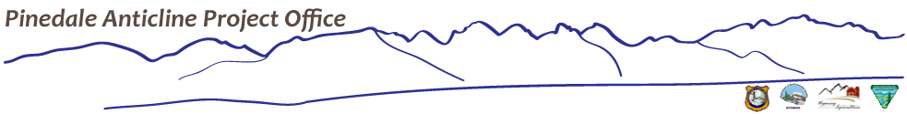

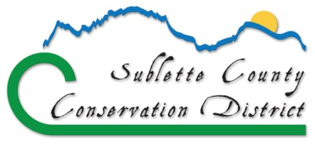

"Local People Making Local Decisions
For Natural Resources In Sublette County"

The Sublette County Conservation District is offering grants up to $2500 to community members for conservation projects. Enclosed you will find the application information and process.

- Applications must be submitted by mail or delivered to the Sublette County Conservation District by end of business on March 1, 2019.
- Grant notifications will be mailed out by April 1, 2019.
- Selected projects must be completed within one year from the project start date, unless otherwise approved.
- A final report will be due 30 days after project completion.

If you have any questions regarding this application or need technical assistance in creating your project, please call the Sublette County Conservation District at 307-367-2257, email mpurcell@sublettecd.com or stop by the office located at the address below.

Sublette County Conservation District
PO Box 647
Hwy 191, 1625 Pine Street
Pinedale, WY 82941

Materials are also posted on our website at www.sublettecd.com

Purpose
Sublette County Conservation District (SCCD) is requesting applications for the “Great Conservation Idea” Grant Assistance Program, sponsored by Pinedale Anticline Project Office and the Sublette County Conservation District. These grants are open to any youth and/or adults, teams, agencies, schools, clubs, church groups, or other civic organizations. This program is available to provide a financial source for your small but “Great Conservation Idea”. We will be looking for ideas that benefit natural resources and which generate small but well thought out projects that might otherwise wither for lack of an appropriate funding source.

key information and funding guidelines
Issues and opportunities in natural resources are vast in our county. Due to the array of possibilities there really isn’t any way to predict what Great Conservation Ideas may be revealed. However, the following outlines some basic concepts which will guide the fund:
- The Grant Assistance Program provides incentives for individuals or groups to be conservationists of natural resources.
- The purpose is to fund small projects that serve great ideas, but aren’t a good fit for other project assistance funds. It is not intended to replace or augment contributions from other project funding sources for projects that cost over $5000.
- Projects may be implemented on Private or Public land, providing proper permission is submitted.
- Applicants will be asked to justify the resource conservation value of the project and provide a final project report.
- All projects must be pre-approved before being initiated and must be evaluated upon completion.
- Projects must provide cost-share in the form of cash or in-kind. The conservation assistance cost-share fund will reimburse up to 50% of project costs where:
- Maximum matching amount is $2500.
- Volunteer “on the ground” labor may be used as in-kind match at the rate of $10/hr.
- Project costs are reimbursable and will be applied based on actual receipts submitted. Unused budget money may not be claimed or kept for personal use.
- Reimbursable purchases should be made within Sublette County, if possible.
- Only one grant may be awarded per individual or group per year.
- Projects cannot improve property for personal monetary gain.
- Projects should normally be completed within one year.
* This opportunity is not meant to provide continual funding for projects that have already received money from this grant assistance program.

eligible participants
Sublette County groups or individuals including residents, landowners, businesses, service organizations, schools, clubs, groups, and other entities interested in conservation. Applicants are free to partner with other organizations for the proposed project. The main responsibility for reporting will lie with the applying organization.

potential projects (See Examples Below)
- Sage-grouse foraging studies (e.g., insect studies, geophagy projects)
- Noise reduction to reduce impacts to wildlife (e.g., during sage-grouse lekking)
- Community enhancement and beautification projects
- Projects to improve habitat for wildlife and livestock
- Watershed projects such as riparian vegetation enhancement
- Noxious weed management for small acreages
- Education and Outreach, especially outdoor learning opportunities.
- Projects that help maintain energy savings and efficiency
- Habitat enhancement for pollinators

expenses (See Examples Below)
- Sagebrush, forbs and seed (project specific)
- Support or materials used for science projects or studies
- Materials such as signs and structures needed for educational opportunities
- Equipment rental related to the project
- Miscellaneous materials such as tape, Ziploc bags, shovels, etc.

ineligible expenses
- Printed materials such as brochures for distribution
- Food for project participants and volunteers
- Paid labor

application
Selection of projects and requested payment decisions will be made by the interdisciplinary Great Conservation Idea Review Team and SCCD Board of Supervisors. Each application will be reviewed to determine which proposals best meet the goals of this grant opportunity. Appropriate permission requests must accompany applications where private or public lands are involved. See the enclosed Application Form.

final report
A final project report is requested and will be due 30 days after project completion. Progress reports may be requested on an as needed basis. The final report should include at a minimum:
- a brief description of your project;
- the goals and objectives;
- site location and methods employed;
- number of volunteers;
- number of people reached, if appropriate
- results and discussion;
- additional outcomes, if any;
- a final budget report; and
- pictures and/or news coverage of the project.

application form

General Information
Project Title:
Group Affiliation: (if appropriate) | Primary Contact Person:
*Mailing Address: *This is how we will notify you regarding project selection
Phone Number: | Email Address:
Briefly describe you and/or your group’s interest and commitment to conservation of Natural Resources:
Project Location and Site Description: (Hand drawn maps and pictures are acceptable and may be attached)

Project Narrative

Goals and Objectives:

Project Benefits/Conservation Value:

Provide a Description of the Project:

Expected Outcomes:

Project Timeline and Monitoring
Project Timeline: Provide a timeline of your project activities and/or describe how you will implement your project.
Expected Project Start Date: |  | Expected Project Conclusion Date:
Monitoring & Assessment Activities:
Project Budget/Cost Estimate Summary

Expenditures |  | Matching Funds
Budget Items/Details: | Cost: | Cash: | In-Kind:
Total Funds Requested |  | Total Matching Funds

* Requested funds cannot exceed total in-kind funds

